**Debian 10**

[**James Kiarie**](https://www.tecmint.com/author/james2030kiarie/)**April 7, 2020 Categories**[**Debian**](https://www.tecmint.com/category/linux-distros/debian/)[**11 Comments**](https://www.tecmint.com/reset-forgotten-root-password-in-debian/#comments)

In this brief tutorial, you will learn how to reset a forgotten root password in a **Debian 10** system. This will help you regain the ability to log in as the root user and [carry out administrative tasks](https://www.tecmint.com/linux-networking-commands/).

So, first power on or reboot your **Debian 10** system. You should be presented with a **GRUB** menu as shown below. On the first option, proceed and press the ‘e’ key on the keyboard before the system starts booting.

[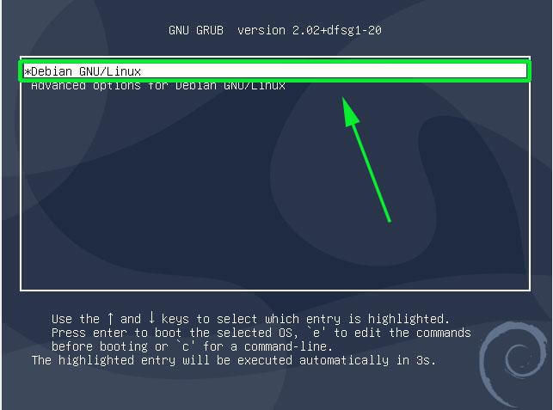](https://www.tecmint.com/wp-content/uploads/2020/04/Debian-Grub-Menu.jpg)Debian Grub Menu

This ushers you to the screen shown below. Scroll down and locate the line that begins with ‘linux’ that precedes the /boot/vmlinuz-* section that also specifies the **UUID**.

[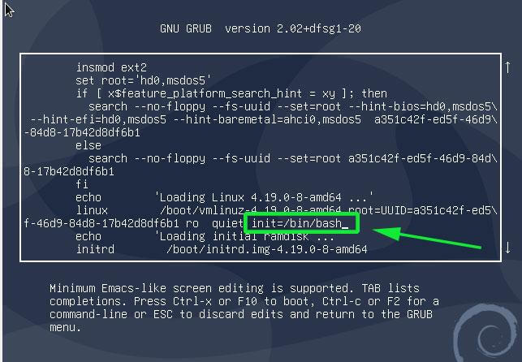](https://www.tecmint.com/wp-content/uploads/2020/04/Grub-Kernel-Parameters.jpg)Grub Kernel Parameters

Move the cursor to the end of this line, just after ‘ro quiet’ and append the parameter init=/bin/bash.

Next hit ctrl + x to enable it to boot in single-user mode with the root filesystem mounted with read-only (ro) access rights.

For you to reset the password, you need to change the access right from **read-only** to **read-write**. Therefore, run the command below to remount the root filesystem with rw attributes.

:/# mount -n -o remount,rw /

[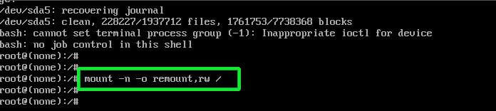](https://www.tecmint.com/wp-content/uploads/2020/04/Mount-Debian-Filesystem.jpg)Mount Debian Filesystem

Next, reset the root password by executing the good old **passwd** command as shown.

:/# passwd

[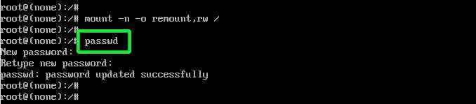](https://www.tecmint.com/wp-content/uploads/2020/04/Reset-Root-Password-in-Debian.jpg)Reset Root Password in Debian

Provide the new password and retype it to confirm. If all went well and the passwords match you should get a ‘**password updated successfully**’ notification at the end of the console

Finally press Ctrl + Alt + Del to exit and **reboot**. You can now log in as the root user using the newly created password that you just defined.

And that’s how you reset a forgotten root password on **Debian 10**.